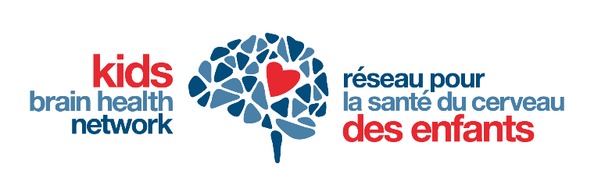

|  |
| --- |
| **Proposal Title:** |
| Impact Statement (2 pages max, 1 inch margins, Calibri font size 11 or larger)  Describe the metrics by which success and impact of the project will be determined (e.g., number of children/families who will benefit from the proposal, number and type of knowledge user organizations, new policies or practices expected from uptake of the innovation, new intellectual property created, new or expanded market for commercialization of innovative solutions). |